UNITED STATES FEDERAL COURT

DISTRICT OF OREGON

CHAL MCCOLLOUGH, ) Civil Case Number:_________________

an individual, )

and members of class ) CLASS ACTION DEFAMATION COMPLAINT AND

INDIE NEWS AND POLITICAL ) DEMAND FOR JURY TRIAL

COMMENTARY )

Plaintiff )

v. )

YouTube (Google LLC) )

c/o Susan Wojcicki, )

Meta, Inc. )

c/o Mark Zuckerberg )

Twitter, Inc. c/o Parag Agrawal )

Wikipedia Foundation )

c/o Katherine Maher, )

and members of class BIG TECH )

Defendant, )

# Plaintiff’s Second Draft Petition

TO THE HONERABLE JUDGE OF SAID COURT:

1. Plaintiff INDIE NEWS AND POLITICAL COMMENTARY (“Plaintiffs”), hereby referred to as Plaintiffs, complains and for causes of action alleges as follows. This defamation action arises from statements made by the class BIG TECH, which consists of a YouTube, Facebook, Twitter, Wikipedia, and a John Doe list of M-4 members, where M is the number of members in the class BIG TECH.

2. BIG TECH spread false and defamatory statements that Plaintiffs were spreading misinformation that the 2020 Presidential election was rigged.

3. BIG TECH spread false and defamatory claims that Plaintiffs were spreading dangerous COVID misinformation.

4. BIG TECH made false claims that Plaintiffs were harassing and bullying people but who never tell us who we were harassing or bulling, or if it was even harassing or bullying.

5. BIG TECH spread false and defamatory statements that Plaintiff were saying hate speech, but they would never tell you what it was that was hate speech.

6. Defendant Wikipedia Foundation unlawfully defamed Plaintiffs as far-right extremists for reporting on the Great Replacement. Democrats strongly dislike the way white Americas voter, and they want to replace the white electorate with a population that is more favorable to Democrats. California is a Sanctuary state that is non-compliant with US immigration laws, Silicon Valley is in California, and BIG TECH is in Silicon Valley, and thus this open border lawlessness has permeated through BIG TECH’s workplace culture leading to BIG TECH firing white males to make the workplace ‘more diverse’, which is anti-white racism. Anti-white racism is common in BIG TECH’s workplace and is encouraged by BIG TECH’s management and executives.

## PARTIES

7. Plaintiff Cale McCollough (hereinafter “CALE”) is a citizen of the United States, residing in Lane County Oregon.

8. Plaintiffs Doe 1, Doe 2, …, Doe N-1 are members of the class INDIE NEWS AND POLITICAL COMMENTARY.

9. Defendant YouTube (Google LLC) c/o Susan Wojcicki is a corporation located at 901 Cherry Ave, San Bruno, CA 94066, United States.

10. Meta, Inc., c/o Mark Zuckerberg is a corporation located at 1 Hacker Way #15, Menlo Park (HQ), CA 94025 USA

11. Twitter, Inc. c/o Jack Dorsey is a corporation located at Twitter, Inc, Market Square, 1355 Market St #900, San Francisco 94103-1307 USA.

12. Wikipedia Foundation c/o Katherine Maher is located at 1 Montgomery St, Unit 1600, San Francisco, CA 94104, United States.

## JURISDICTION AND VENUES

13. This Court has subject matter jurisdiction pursuant to 28 U.S.C. § 1332 because there is a complete diversity of citizenship between Plaintiffs and Defendants and the amount on controversy exceeds $75,000.00, exclusive of interest and costs.

14. This Court has Personal Jurisdiction over YouTube (Google Inc.) because YouTube (Google Inc) is a domestic for-profit corporation registered in California in Silicon Valley.

15. This Court has Personal Jurisdiction over Twitter, Inc because Twitter, Inc is a domestic for-profit corporation registered in California in Silicon Valley.

16. This Court has Personal Jurisdiction over Meta, Inc because Meta, Inc is a domestic for-profit corporation registered in California in Silicon Valley.

17. This Court has Personal Jurisdiction over Wikipedia Foundation because Wikipedia Foundation is a domestic non-profit corporation registered in California in Silicon Valley

18. Venue is proper in this Court under 28 U.S.C. § 1391(b)(1) because at least one of

the Defendants resides in Eugene Oregon. Venue is also proper in this Court under 28 U.S.C. § 1391(b)(2) because a substantial part of the events or omissions giving rise to the claim occurred in Eugene Oregon, and under 28 U.S.C. § 1391(b)(3) because at least one of the Defendants is subject to the Court’s personal jurisdiction regarding to this Action.

## FACTUAL ALLAGATIONS

### The False and Defamatory Articles

19. This class action lawsuit revolves around BIG TECH unlawfully defaming Plaintiffs by BIG TECH making and spreading lies to billions of people maliciously painting Plaintiffs as dangerous content that should be banned, resulting in a cascade of injury to the Plaintiffs.

### Defendants ignored their obligation

### to investigate the truth of their claims

### and instead published fabricated evidence

20. Defendants published the false statements in the Article with knowledge of the

falsity of those statements or with reckless disregard for the truth.

### INDIE NEWS AND POLITICAL COMMENTARY has been harmed by the article

21. Each member of the class INDIE NEWS AND POLITICAL COMMENTARY has been harmed in different ways that members of the class shall enumerate in the Declaration in Support of Petition.

3. BIG TECH mad defamatory statements to each Plaintiff, and BIG TECH published that our accounts and content has been taken down.

4. BIG TECH made false statements of fact, not opinion, that Plaintiffs bullied and harassed, spread misinformation, and spoke hate speech.

5. Hearer of the statement heard, understood, and the statement meant, and that Plaintiffs were alleged to have dangerous content that may lead to the users being banned or reduced visibility if they are subscribe, read, listen to, or watch Plaintiffs content.

6. BIG TECH has damaged Plaintiffs reputation by artificially creating a false perception of unpopularity by artificially reducing our views and revenue and caused depreciation on our studio equipment and costs related to producing content during the periods where the Defendants were engaging in the unlawful activities.

7. BIG TECH has exposed Plaintiff to hatred, contempt, ridicule, and obloquy, caused plaintiffs to be shunned and avoided, and has a injured the plaintiff in our occupations.

8. BIG TECH does not have Privilege to make the false claims because (a)the claims were made with malice and reckless disregard, (b) the statements were not made to employees but were made to the public, (c) The statements were not made to prospective employers with common interests under California Labor Code Section 1050 but were made to the General public which includes employers that do not share common interests with BIG TECH.

9. BIG TECH hates the Plaintiffs for their behavior and acted in reckless disregard for Plaintiffs.

10. BIG TECH lacked all reasonable grounds that the users had harassed, bullied, spoken hate speech, or spread misinformation because BIG TECH is too big to moderate, they use dumb bots that can’t tell context and were trained by people who are hostile to Republicans, and BIG TECH has used what limited moderation resources to target the political enemies of the advertisers and Democrats, resulting in a flood of so many content take downs that it was impossible to moderate all of the content. Just like in China’s surveillance State BIG TECH chose to use the limited processing power to target their political enemies, targeting and defaming Plaintiffs and preventing them from monetizing their works.

11. BIG TECH’s policies prevent from linking to content in violation of their policies, so BIG TECH effectively removed Plaintiffs.

12. BIG TECH caused billions of US dollars in damages when they made large volumes of false claims about Plaintiffs violating their community guidelines.

13. BIG TECH defamed Plaintiffs through the use of unsupervised learning AI bots trained on unlabeled data that had a dangerously high rate of false positives. BIG TECH did not use a human to manually label the training. Instead, BIG TECH allowed the bots to auto-generate their own classifications. BIG TECH frequently made false accusations that Plaintiffs was harassing and bullying people, but they would never tell you who the victim was.

14. BIG TECH has billions of users, is a corporate town, and is so powerful that BIG TECH can, has, and will in the future determine the outcome of US elections through their policies.

15. BIG TECH operates out of Silicon Valley California, which is a Democrat stronghold that receives upwards to 95% of votes in elections. The vast majority of BIG TECH employees vote for Democrats.

16. The Democrat party has been engaging in election engineering through electorate packing by opening the US southern border to human smuggling. Democrat’s objective is to engineer the outcome of elections to resettling economic migrant families to swing voting precinct. By Democrats favoring illegal immigration and giving SNAP (better known as ‘food stamps’) and welfare benefits to illegal immigrants, it causes first generation Latino children to vote blue no matter who, which means to will be life-long Democrat voters. This is called the Great Replacement, but the United Nations calls it replacement migration. BIG TECH has defamed anyone who believes in Great Replacement as dangerous and has banned them from their platforms. In the BIG TECH workplace, White people who oppose mass and illegal immigration are smeared as white nationalists, creating a hostile work environment.

17.

# 2. Discovery

1. Plaintiff respectfully requests Discovery in this case be conducted under Oregon Rules of Civil Procedure (hereby referred to as ORCP) Rule 36(A).

# 3. Request for Disclosure

Pursuant to Rule 36(A) of the Oregon rule of Civil Procedure, within thirty days of service of this request, the information and material described in Rule 36(A) of the Oregon Rules of Civil Procedure. Plaintiff specifically requests the responding parties to produce responsive documents at the undersigned law offices within 30 days of service of this request.

## 4. Demand

We the Plaintiffs/Petitioners, Plaintiffs, demand the Defendant, BIG TECH, give us $1.6 billion in compensation for damages from defamation of character and antitrust violations. This is an official notice to settle a lawsuit. You will receive a printed copy of this letter and the last letter I sent via email, and you have one month to settle before this Petition is filed with the US Federal Court system. Parties.

## Parties

The before listed entities are hereby collectively referred to as Plaintiffs and consists of a class of affected people with N members.

## Cases

1. In **Marsh v. Alabama, 326 U.S. 501 (1946)** the Court decreed the US Constitution is supreme in corporate towns and corporate towns are not allowed to deny it's citizens First Amendment rights.

## Statement of Points and Authorities

1. The **First Amendment** to the US Constitution commands "Congress shall make no law respecting an establishment of religion or prohibiting the free exercise thereof; or abridging the freedom of speech, or of the press; or the right of the people peaceably to assemble, and to petition the government for a redress of grievances."
2. **47 US Code § 230** **(a)(3)** finds that "The Internet and other interactive computer services offer a forum for a true diversity of political discourse" and subsection (c) states the intention of the section is 'Protection for “Good Samaritan” blocking and screening of offensive material'.
3. **The Sherman Act of 1890** provides a "comprehensive charter of economic liberty aimed at preserving free and unfettered competition as the rule of trade."
4. **52 U.S. Code § 20701** requires every officer of election shall retain and preserve election related material for a period of twenty-two months from the date of any general, special, or primary election of which candidates for the office of President or Vice President.
5. **CA Civil Code § 45**
6. Under **28 U.S. Code § 4101(1))**, the term “defamation” means any action or other proceeding for defamation, libel, slander, or similar claim alleging that forms of speech are false, have caused damage to reputation or emotional distress, have presented any person in a false light, or have resulted in criticism, dishonor, or condemnation of any person.

## FACTUAL ALLEGATIONS

### The defamatory article

A. BIG TECH consists of a network of platforms that are not protected under 47 US Code § 230.  
B. BIG TECH has unlawfully censored Plaintiffs' news that Chinese government spies and other hostile State actors have infiltrated Silicon Valley and they have a network that reaches up to the White House.  
C. B. BIG TECH is a Silicon Valley Monopoly.­­­­­  
D. BIG TECH is a community of families including children under age 13 and is too large to moderate.  
E. BIG TECH takes on national security and election official roles.  
F. BIG TECH is a corporate town.  
G. BIG TECH censors on behalf of Democrat Politicians to censor Republicans and Plaintiffs and this is an illegal campaign contribution.  
H. BIG TECH banned former US President Donald Trump to influence US politics.  
I. BIG TECH unlawfully bans Plaintiffs for criticizing religion and politicians.  
J. BIG TECH unlawful censored alleged COVID and Medical misinformation.  
K. BIG TECH unlawful censored news, commentary, and critique of ballot harvesting and related election fraud.  
L. BIG TECH censors US Citizen's speech on the behalf of foreigners and hostile foreign governments like China.  
M. BIG TECH profited from enabling BLM riots and scam fundraisers on their platform.  
N. BIG TECH profits from and props up Big Media who gas light with false claims that prevents citizens from getting fair trials.  
O. BIG TECH fortified Biden and suppressed Trump in the 2020 Election in a 'shadow campaign' of election engineering.  
P. BIG TECH biases search results in favor of Big Media and does not classify Plaintiffs as real news.  
Q. Wikipedia is one of the primary sources of defamation and the Wikipedia Foundation has banned Plaintiffs publishing false facts maliciously and recklessly that INDIE NEWS AND POLTICAL COMMENTARY that we’re Nazis for adding proof of QAnon and Great Replacement..

R. BIG TECH has defamed and caused psychological and emotional injuries to Plaintiffs members as described in each member's "Declaration in Support of Petition".  
S. BIG TECH caused $1.6 billion in tort-actionable damages to Plaintiffs.  
T. This Court has jurisdiction over the questions of law at hand and this is the most suitable Court to hear these questions of Federal Law:

1. Does BIG TECH have a monopoly based on Silicon Valley?
2. Is BIG TECH a corporate town?
3. Is BIG TECH monopolizing the content licenses for Plaintiffs’s videos, comments, and other content?
4. Is BIG TECH's used sophisticated AI algorithms to modify the public's behavior through psychological manipulation protected under 47 US Code § 230?
5. Has BIG TECH unlawfully censored Plaintiffs using 47 US Code § 230 on behalf of Democrats?
6. HAS BIG TECH caused damages to Plaintiffs and are they liable for the damages?

### A. BIG TECH consists of a network of platforms that are not protected under 47 US Code § 230.

47 US Code § 230 provides protections from for 'Good Samaritans' to filter offensive obscene, lewd, lascivious, filthy, excessively violent, harassing, or otherwise objectionable material. BIG TECH consists of networks of platforms that the gestalt provides the internet as we know it and is not covered under 47 US Code § 230 because acts by a monopoly to artificially preserve that status, or nefarious dealings to create a monopoly, are not the actions of Good Samaritans because it would be a violation of the Sherman Anti-trust Act.

### B. BIG TECH has unlawfully censored news that Chinese government spies and other hostile State actors have infiltrated Silicon Valley with a spy network that reaches up to the White House.

Silicon Valley has been infiltrated by Russian and Chinese government spies who are performing what the CIA calls Rob, Replicate, and Replace strategy to replace the US as the world's number one superpower. Spies such as the notorious Chinese spy Fang Fang who slept with the US House of Representatives member from the 15th District of California, which is in Silicon Valley, have attained a spy network that reaches all the way up to the White House. US President Joe Biden's son Hunter Biden is a notorious crack addict who has sex with hookers while smoking crack. Hunter Biden has been in the media for him taking millions of US dollars for the Chinese Government and the Ukrainian energy firm Burisma to sell access to Joe Biden.

BIG TECH has unlawfully censored Plaintiffs by pulling advertising funds from channels critical of China, citing that the channels were "controversial". Plaintiffs's speech that was censored did not violate platform rules, BIG TECH reduced visibility and in cases such as articles about Hunter Biden's laptop that Hunter left at a laptop repair company but never picked up. Twitter censored the New York Post article "Smoking-gun email reveals how Hunter Biden introduced Ukrainian businessman to VP dad " in order to fortify Biden in the 2020 election and suppress Trump.

On Hunter Biden's laptop there exists an email with a business partner Hunter's called “the chief spy of China”, a 29-year-old Chinese-American assistant named JiaQi Bao, assigned the president’s son a Chinese-American secretary who was feeding him opposition research to help Joe Biden’s 2020 election bid after the business venture collapsed in 2018, the Daily Mail reported Friday, May 7, 2022, and also revealed that day:

After launching his multi-million-dollar joint venture with CEFC, Hunter was assigned a 29-year-old Chinese-American assistant, JiaQi Bao, who quickly struck up a close and intriguing relationship with her Biden boss.

At first, emails show the New York-based Bao diligently scheduled flights, hotels, and even doctor’s appointments for the president’s son.

But mysteriously, the young assistant also sent him opposition research to help Joe Biden’s 2020 election bid, urged him to take cash from the joint venture’s accounts as the business collapsed and wrote flirty and personal messages and even ended up with Hunter’s military dog tags in her New York apartment – the same tags he can be seen wearing in home-made porn videos he recorded on his laptop.

After the joint venture had dissolved, Bao emailed Hunter with a conspiratorial message encouraging him to help his father run for president and listing talking points to combat criticism of Hunter’s dealings with the Chinese.

After partnering with Chinese oil giant CEFC in the multi-million-dollar deal, Bao was appointed as his secretary and assistant, acting as a go-between for his Chinese business partners, translating documents and performing clerical work for Hunter in the joint venture.

As Hunter’s joint venture with the Chinese began to crumble that month amid the arrests of its two leaders, Bao wrote one of her most surprising emails encouraging him to raid the coffers of one of Hunter and CEFC’s joint corporate vehicles called Hudson West.

### C. BIG TECH is a Silicon Valley Monopoly.

Big Tech is a monopoly in Silicon Valley California. About 86% of Silicon Valley votes for Democrats. Big Tech founders, Mark Zuckerberg, Jack Dorsey, and all know each other. Big Tech works as one to maintain their monopoly. The relationships of the higher ups in BIG TECH have metaphorically incestuous relationships. The come up in Silicon Valley you must do so through the circles under control of BIG TECH and their investors.

### D. BIG TECH is a community of families including children under age 13 and is too large to moderate.

BIG TECH has been performing wide-scale psychological manipulation of the American public using advanced AI algorithms along with paid human predicted class classification to change the behavior of people to make their speech more advertiser friendly in the most countries as possible. A long time ago there used to be corporations that owned entire towns called corporate towns. These towns are governed under the US Constitution [1]. Big Tech has attained a monopoly that is akin to a corporate town, almost everyone in the US is on Big Tech, including children who watch YouTube regularly. Many people's entire lives are wrapped up into their online persona, which is their brand. The sheer volume of content that requires moderation on BIG TECH platforms, requiring armies of paid moderators who can get PTSD from looking at obscenities like animal cruelty. There is obviously a need to keep this obscene, lewd, lascivious, filthy, excessively violent, harassing, or otherwise objectionable, whether or not such material is constitutionally protected away from where it can cause harm. The problem is when if you want to entire the market, that you require massive investment to fund moderators with hyper sophisticated AI technologies and if you don’t have this technology, they'll shut you down like they did Parler.

### E. BIG TECH takes on national security and election official roles.

“Wherever the readers are, wherever the viewers are, that is where propaganda reports must extend their tentacles.” - Xi JinPing, February 2016

On October 19, 2020, California Attorney General Xavier Becerra, a Democrat preceded by Kamala Harris, sent a letter to Mark Zuckerberg, CEO of Facebook, Jack Dorsey, CEO of Twitter, and Susan Wojcicki, CEO of YouTube urging Big Tech to suppress content critical of mail-in voting, that Russians were perpetrating a disinformation campaign to stoke racial resentment, 'suppress' non-white votes, and sow distrust in our election system.

The letter reads:

"The State of California Has a Mandate to Protect its Citizens’ Voting Rights.  
California has a significant interest in protecting its citizens’ constitutional right to vote. State laws protect citizens by, for example, prohibiting interference with voting rights through violence, threats, intimidation, and other coercive conduct (see, e.g., Civ. Code, § 52.1(b); Elec. Code, §§ 18502, 18540). State laws also prohibit knowingly distributing intentionally misleading information about the time, place, manner of voting, and voter eligibility (see, e.g., Elec. Code, §§ 18302, 18543). To further protect voters, state law requires social media companies that sell political advertisements to disclose who funded certain political advertisements and maintain an online record of such advertisements for public inspection (see, e.g., Gov. Code, § 84504.6).

The California Department of Justice will not hesitate to enforce these laws against any individual or group that violates them. However, given social media’s prominence and influence in American political discourse, you share a responsibility to use the tools at your disposal to combat the dissemination of disinformation that interferes with our electoral system and to report any illegal activity detected on your respective social media platforms that interferes with Americans’ right to vote. "

The use of the word However in the preceding sent is a direct threat to Big Tech that the District Attorney will use everything in his power, which includes filing antitrust action against Big Tech to break them up. The letter then uses the citation "Senate Report Vol. II, supra n.2 at p. 3", which is the Russiagate Report. Senator Kamala Harris sat on the Senate Select Committee for Intelligence behind the politically motivated Russiagate witch hunt conspiracy theory that stoked hatred of Donald Trump and his supporters, stoked riots, terrorized America for almost a year of non-stop hate and hostility and violence, and occupied our times with Big Media's constant gas lighting of Donald Trump. Big Media journalist piggy backed Trump's fame by constantly making up stories based on things Trump said that would #triggered people, meaning it gas lighted people. Currently former President Trump is on a 2-year suspension from Facebook, but he publicly states he will be running in 2024.

### F. BIG TECH is a Corporate town that tracks each citizen around the internet and in the real world via mobile devices that collect medical and election information.

BIG TECH has tracking technologies installed into almost all their apps that constantly monitor US citizens everywhere, giving BIG TECH owners and executives privileged access to Big Data that they use to maintain their monopoly. You can't go anywhere anymore without BIG TECH knowing exactly where you are, and in many cases BIG TECH is even listening to you or watching you through your computer's webcam and microphone. When you take a poop, BIG TECH knows if you have your smartphone with you. When you go to your doctor, BIG TECH knows who your doctor is. BIG TECH can use this information to deduce citizen's medical information that might violate HIPA. When citizens drop their ballots off, BIG TECH knows when you did and what your political party is. This gives BIG TECH the ability to manipulate elections through ballot harvesting where they remove votes from the party, they want to lose using their spy technology to which ballot harvesting boxes have the most Republican and Democrat votes.

The children of Plaintiffs also are highly active on BIG TECH PLATFORMS, even if they are under age 13 children often use their parent's YouTube account. The children of some of Plaintiffs spend hours per day watching YouTube videos, which is more time than they spend engaging in school. Plaintiffs also publicly performs independent news and political commentary for the general public when users with BIG TECH accounts display the content to users who do not have BIG TECH accounts and did not consent to their terms of service.

Foreign companies and State actors for governments such as China and Russia can utilize AI algorithms to manipulate the behavior of children through BIG TECH platforms. This means that BIG TECH is some of the only businesses in the Country that require the US Military and Intelligence Agencies in order to even exist. Without the US Military and Intelligence Agencies BIG TECH would be the largest military threat to the US. Presence of children, families, and US citizens who grow up on BIG TECH platforms and must live their entire lives under their rules and they face existential military threat and constant expose to Chinese military and intelligence agency hacking and cyber war, BIG TECH is a corporate town. Many members of Plaintiffs have grown up themselves on BIG TECH platforms and had exposure to BIG TECH's AI algorithmic behavior modification technologies.

### G. BIG TECH banned former US President Donald Trump to influence US politics.

BIG TECH banned US President Donald Trump citing violations of platform rules. BIG TECH supported Joe Biden and opposed Donald Trump. BIG TECH banned President Trump with the intent to influence US politics.

### H. BIG TECH censors on behalf of Democrat Politicians to censor Republicans and Plaintiffs and this is an illegal campaign contribution.

In the October 19, 2020 letter from California Attorney General Xavier Becerra to Mark Zuckerberg, Jack Dorsey, and Susan Wojcicki in Argument D, the Democrat AG that sits in Vice President Kamala Harris's current seat who used information from the Russiagate Senate Selection Committee on Intelligence behind the political prosecution of Donald Trump, BIG TECH was urged to work to suppress Donald Trump citing that Russians were trying to put out disinformation so they had to fortify Biden and suppress Trump.

On March 15, 2020, Mark Zuckerberg sent an email to Dr Anthony Fauci, the head of the President of the U.S. National Institute of Allergy and Infectious Diseases. In this email Zuckerberg starts referring to Fauci as Tony and says, "As a central part of this hub, I think it would be useful to include a video from you because people trust and want to hear from our experts rather than just a bunch of agencies and political leaders."

Because BIG TECH is censoring on behalf of Democrat politicians to suppress Republicans and Plaintiffs and prop up the Democrat's narrative, this constitutes an illegal campaign contribution.

### I. BIG TECH unlawfully bans Plaintiffs for criticizing religion and politicians.

Twitter suspended RSS Commentary for multiple months and the ban is still active for criticizing Islam for the following Tweet.

[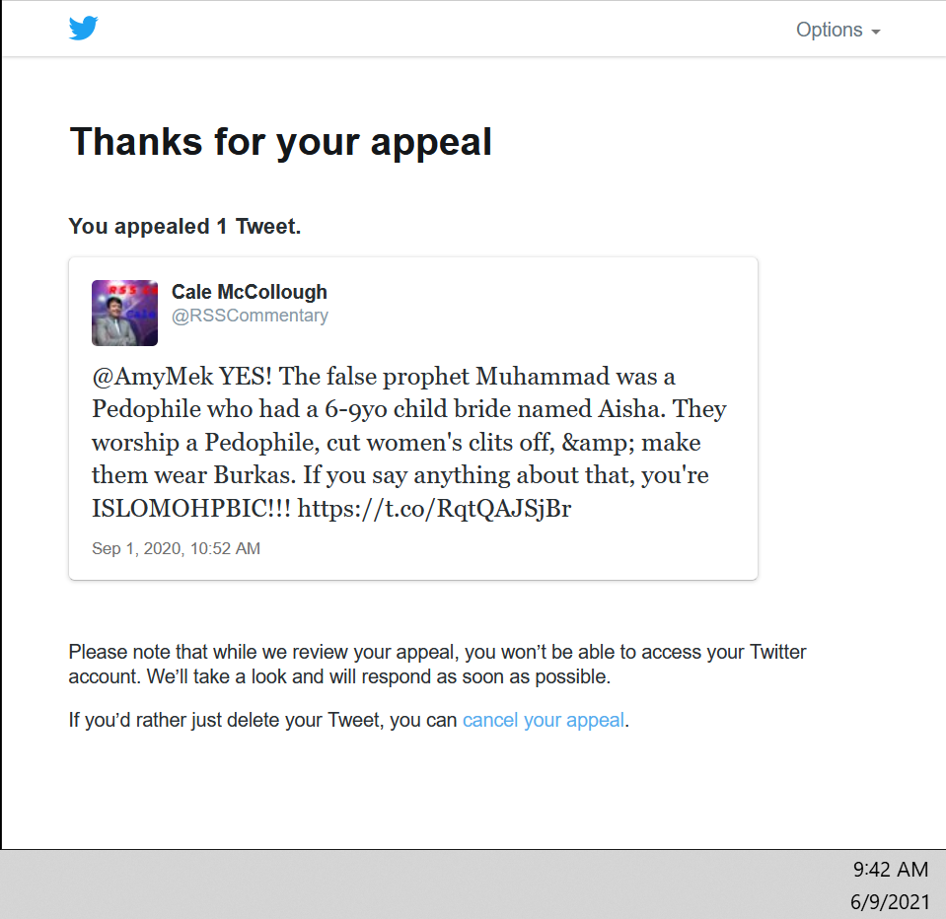](https://user-images.githubusercontent.com/6005325/121395270-163d4400-c907-11eb-99cc-dc4fdb291295.png)

Twitter again suspended RSS Commentary for criticizing Kamala Harris.

[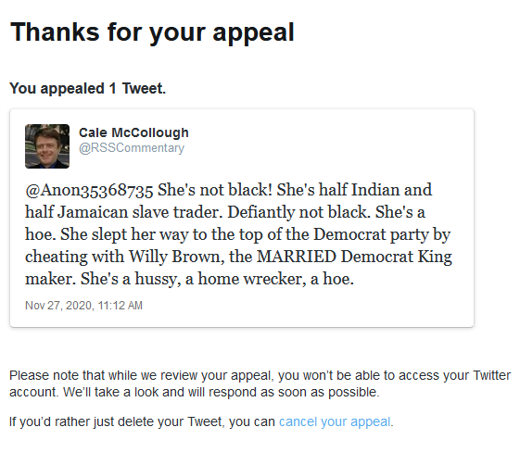](https://user-images.githubusercontent.com/6005325/121403697-06762d80-c910-11eb-99a6-277edfe0d652.png)

Twitter also suspended RSS Commentary for criticizing Rep. Tom Malinowski, D-N.J., and Rep. Denver Riggelman, R-Va. for their introduction on a bill to condemn QAnon around August 26, 2020. Cale McCollough said the law makers might be pedophiles for condemning QAnon. That screen shot is unavailable due to Twitter deleting it. After this tweet was taken down, Cale McCollough reported being Shadow banned, which is where a platform, Twitter in this case, removes a profile from public visibility. BIG TECH shadow bans accounts for political reasons that are not ‘Good Samaritan’ actions.

Facebook suspended Cale McCollough and he was unable to like President Trump's video on Facebook to show his support.

[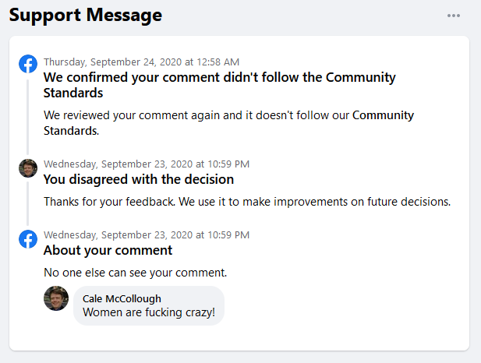](https://user-images.githubusercontent.com/6005325/121571374-ca0e0480-c9d7-11eb-9625-69b6f92a36ec.png)

[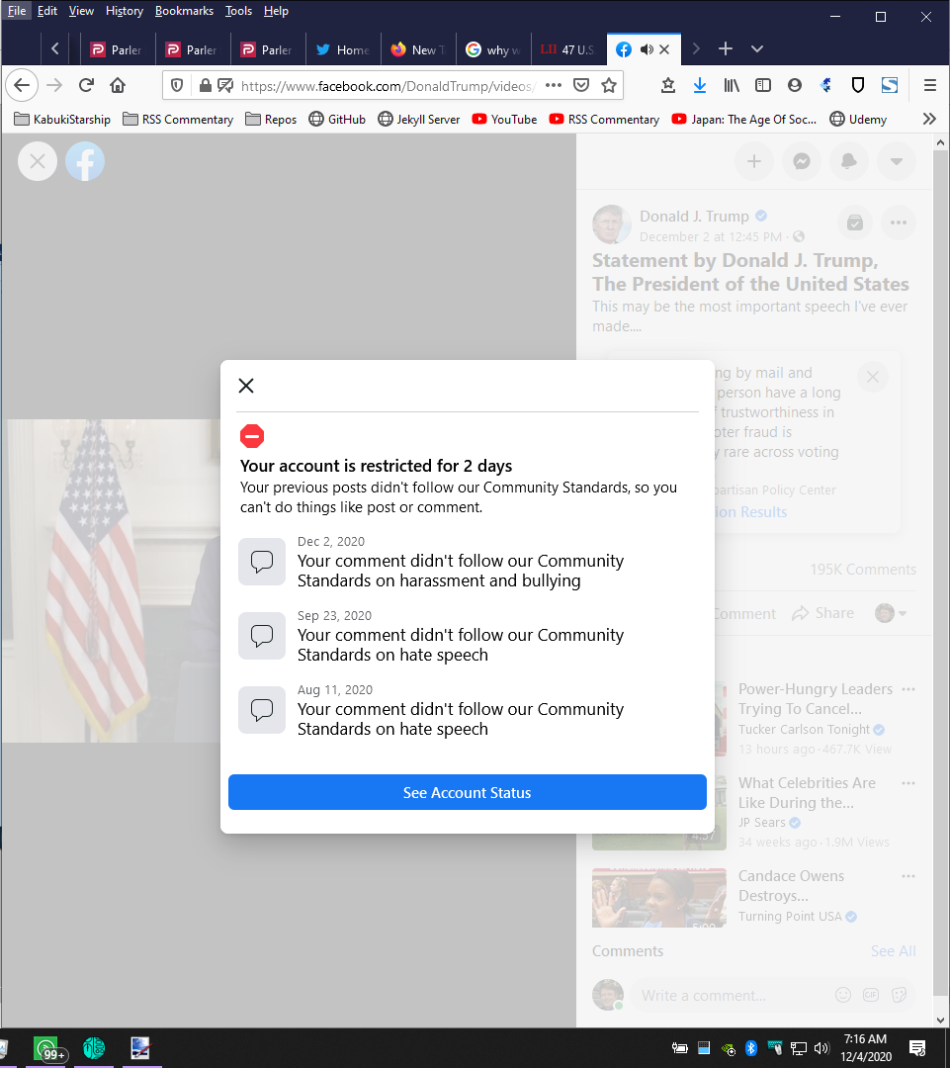](https://user-images.githubusercontent.com/6005325/121403896-40473400-c910-11eb-9522-01d2f3e40e8e.png)

Facebook suspended Cale McCollough for criticizing Black Lives Matter protestors.

[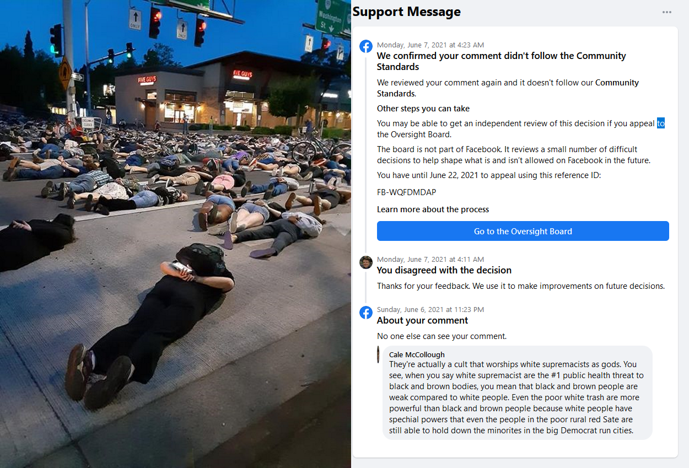](https://user-images.githubusercontent.com/6005325/121565219-21f53d00-c9d1-11eb-9e02-7a2997fc2a23.png)

Currently Cale McCollough is unable to like posts on the White House's official Facebook page.

[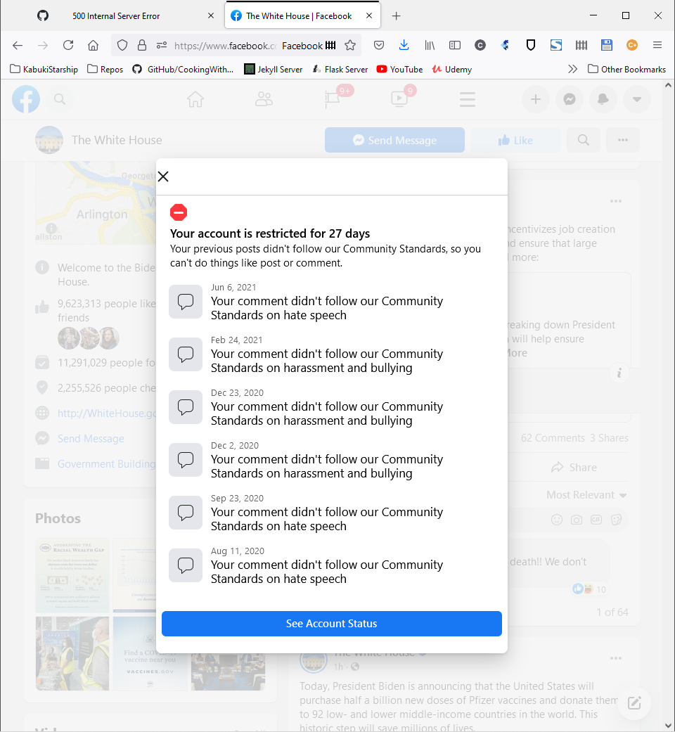](https://user-images.githubusercontent.com/6005325/121583703-71ddff00-c9e5-11eb-890a-85a0b9d8a3a5.png)

Facebook removed Cale McCollough's fact check of the Brennan Center for Justice's article Hidden in Plain Sight: Racism, White Supremacy, and Far-Right Militancy in Law Enforcement that showed the article was just making a big deal over nothing. As much as you may detest white supremacists, they do have the right to work in law enforcement and government. Disliking non-whites is not actually a sin, contrary to popular belief.

[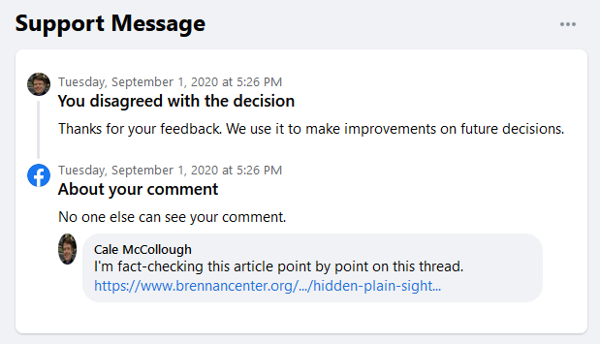](https://user-images.githubusercontent.com/6005325/121573818-84067000-c9da-11eb-9147-84d832dc68a5.png)

Facebook removed Cale McCollough's comments criticizing Black Lives Matter in the following censored comments.

[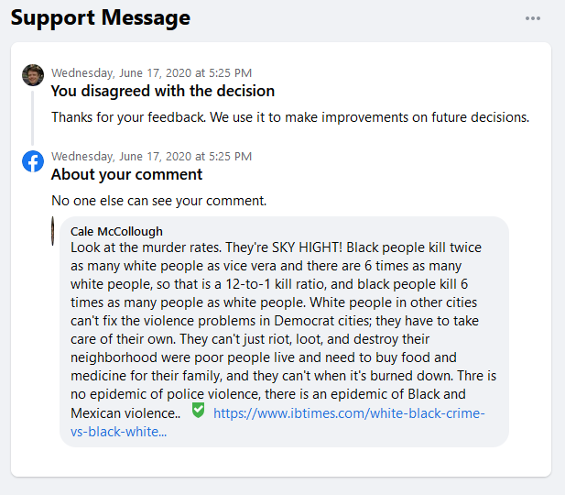](https://user-images.githubusercontent.com/6005325/121573672-5f11fd00-c9da-11eb-86b4-9f601757d4e7.png)

### J. BIG TECH unlawful censored alleged COVID and Medical misinformation.

Nowhere in 47 US Code § 230 does it give any protection for companies screening misinformation. YouTube censored multiple Plaintiffs videos for use of the CDC chart entitled `U.S. Deaths from Coronavirus by Age Group (Feb. 1 - June 17, 2020).

Some of the COVID misinformation on YouTube that gets censored is legitimately misinformation, but news presenters and commenters aren't given the ability to fact check their own content. YouTube has access to advanced AI algorithms to detect misinformation faster than content creators can detect and thus are unable to self-fact check due to Google's AI dominance. RSS Commentary had some videos taken down for what at the time was the most accurate information there was at the time on the projected deaths of COVID-19 in the following chart. When RSS Commentary did become aware the videos contained misinformation Cale McCollough took down the videos that contained the known misinformation. However, it is not possible on YouTube to just clip out a section and insert a fixed section without resetting the video’s like count, which can devastate to a video's view count leading to financial damages to Plaintiffs. No option was given to trim out the misinformation out of the video.

[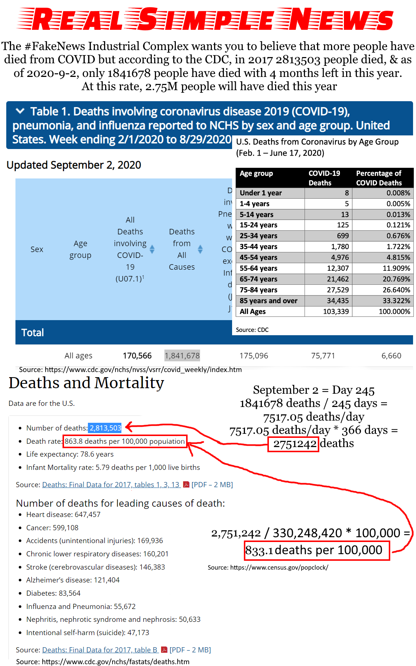](https://user-images.githubusercontent.com/6005325/121064862-f417ba80-c77c-11eb-8be8-b2724a73c7a9.png)

YouTube cites that videos that only showed the CDC Chart of COVID deaths by age for alleged Medical Misinformation that goes against World Health Organization guidelines.

RSS Commentary appealed to censorship in the following response, but the appeal was denied.

This video does not contain medical misinformation. YouTube is engaging in anti-competitive practices against indie news channels like RSS Commentary in order to get Democrat politicians to not break up Big Tech. The CDC admitted recently there were NEVER any information proving masks would slow COVID spread and the Facui also backpedaled and said COVID probably came from the Wuhan Lab. The purpose of this strike is to censor indie news going forward to bias the narrative towards Democrats so Republcians will never gain power to break Alphabet, Facebook, & Twitter up. Accroding to the US NIH, most Spanish flu deaths were from bacterial pneumonia, most likely source was the masks. I'm an engineer who's made a COVID ventilator, I now WAY more than you. You know know nothing compared to me.

Please note Fauci was misspelled Facui, Republicans was misspelled as Republcians and according was misspelled as Accroding.

[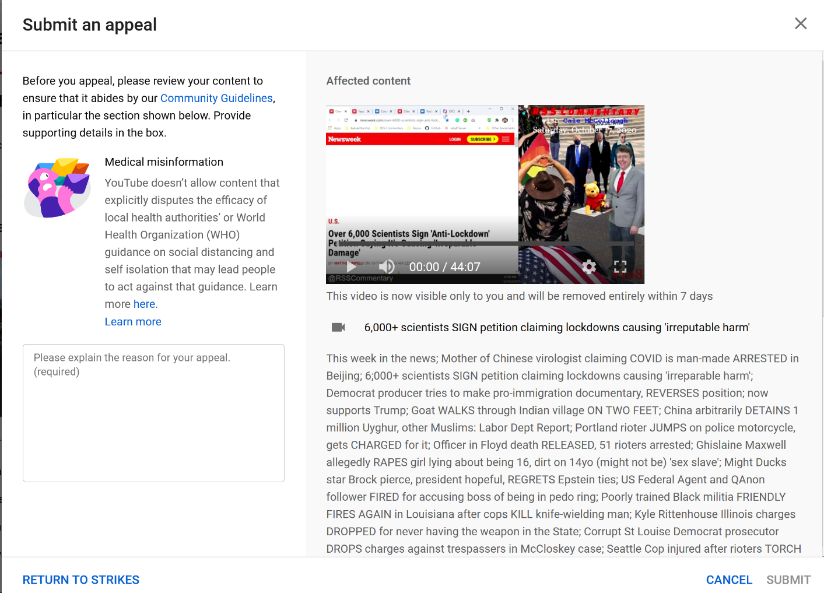](https://user-images.githubusercontent.com/6005325/121565992-e6a73e00-c9d1-11eb-8152-5c66ca43ab37.png)

RSS Commentary regularly criticizing the World Health Organization and thus this rule makes RSS Commentary's videos contain WHO criticism commercially inviable.

At some point this year the CDC updated the death tolls and there were dramatically more deaths than projected. The CDC has overhauled their website located at

<https://www.cdc.gov/nchs/covid19/mortality-overview.htm>

entitled "COVID-19 Mortality Overview", the total number of COVID deaths has been through the week ending 5/29/2022, 583,025 deaths, and approximately 647,312 excess deaths, which is a mid-point between 580,751 to 713,873 deaths. Subtracting the maximum number of excess deaths, and there are up to 130,848 excess deaths beyond the reported COVID deaths. Many of these deaths are due to lockdowns and mask mandates causing explosions of disease as will explained in a later argument section. At the time of the publishing of the above chart that does after the fact include misinformation, we didn't know how many people would die, but it was known that overreacting to COVID might cause excess deaths, and by averaging out the deaths for multiple years the number of deaths may still average out to approximately the same number of deaths as was expected before COVID-19 broke out.

Facebook censored Cale McCollough for alleged spam for criticizing lockdowns, mask mandates, and Big Media when he linked to the CDC article Coronavirus Disease 2019 in Children — United States, February 12–April 2, 2020 in the following comment.

[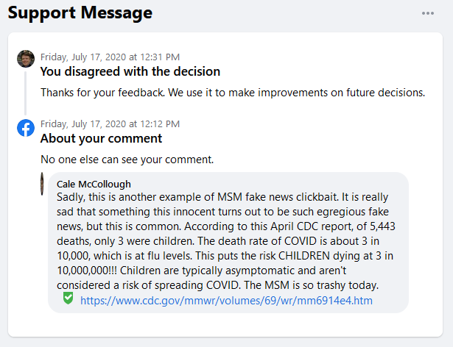](https://user-images.githubusercontent.com/6005325/121576078-e6607000-c9dc-11eb-82f2-35f975772827.png)

### K. BIG TECH unlawful censored news, commentary, and critique of ballot harvesting and related election fraud.

Big Tech has engaged in coordinated censorship of Election fraud information, including Ballot harvesting as a method of fraud. YouTube censored the RSS Commentary video entitled "Facebook BANS 'Stop the Steal' political movement, hashtags". In this video Cale McCollough called ballot harvesting election fraud, causing the video to get flagged for Election Misinformation and taken down.

Ballot harvesting is the act of private individuals collecting mail-in ballots. Ballot harvesting is voter fraud for the following reasons.

1. Computer vision scanner apps for mobile devices allow ballot harvesters to detect the party of the voter by taking a picture of the ballot signature and matching it to their voter registration data and to throw out Trump votes.
2. Ballot harvesting rings can target BIG TECH users with AI and psychological manipulation right before they send ballot harvesters to pick up their ballots.
3. Most Democrats live in big cities that are vastly more dense populations than small-to-medium sized cities and rural areas making ballot harvesting and social media election engineering significantly more effective.
4. Most Republicans live in small to medium sized cities with significantly lower population density than Democrat strongholds making ballot harvesting and social media election engineering less effective.
5. Mail-in Voting and ballot harvesting dramatically biases elections towards Democrats because most Democrats live in big cities where the density of people is dramatically higher, and Democrats can rig the election by paying ballot harvesters to harvest private votes, Democrats will always win due to how many extra miles are needed to traverse to collect the ballots in rural areas where most Republicans live.
6. BIG TECH platforms facilitate ballot harvesting election fraud by isolating voters behind echo chambers where facts are ignored by violent mobs who have been gas lighted with rage-bait click-bait by the journalist BIG TECH approves to be artificially promoted above INDIE NEWS AND POLTICIAL COMMENTARY.
7. Ballot harvesting encourages Sanctuary nation and Sanctuary state policies to boost the population of urban areas that typically vote for Democrats over rural areas which typically vote for Republicans.

The first resolution passed by the Democrat-controlled US House of Representatives in 2022 was HR1, the “For the People” Act, hereby referred to as HR1, which has not passed the Senate yet, would legalize national wide vote by mail with same day online registration without ID requirements and it would legalize ballot harvesting nationwide. The US Constitution doesn’t say anything about how to conduct elections, it explicitly delegates running of elections to the States. The reason why is because that is because HR1 would give Democrats permanent control over US electoral politics when combined with the Biden-Harris open-boarder Sanctuary nation policies that has caused an explosion of illegal board crossings and cartel human, meth, heroin, Chinese fentanyl, cocaine, and, and crack smuggling and mass murder and rape of migrant human trafficking victims. Most illegal immigrants congregate in large cities in mono-ethnic cities. After the illegal immigrants' children grow up, they are more likely to vote for the party that is trying to stop their parents from being deported. There are housing shortages in most major cities, and this is causing a huge spike in rent and homelessness. The Democrats get to grab the power by drowning out the rural conservatives' votes through ballot harvesting in more dense cities, but the low-income people in the big cities become a permanent underclass and Americans get pushed out of the big cities by the rent increases, or they flee for Red States for lower taxes to get away from the failed Democrat policies. Ballot harvesting is election fraud that encourages harboring illegal immigrants, and BIG TECH's censorship of ballot harvesting information is not lawful.

### L. BIG TECH censors US Citizen's speech on the behalf of foreigners and hostile foreign governments like China.

BIG TECH doesn't censor speech because it's offensive, BIG TECH uses sophisticated AI algorithms that psychotically manipulate users to change their behavior to maximize the amount time spend on the platform. Facebook users are Facebook's number 1 products, and they receive approximately $7 profit per user per year. The primary source of BIG TECH's money is from advertising from corporations that are either foreign owned, owned by Chinese 'Communist'/Nazi Party officials, hereby referred to as CCP, or they are corporations who are expanding into the Chines market. China is not communist. Communist is a bottom-up rule by the community with a powerful central State that organizes the communist economic machine.

Communism is based on Marxist dielectric materialism, which is where the proletariat (meaning workers) rises up and smashes the bourgeoisie (meaning land and business owning classes, typically white people). In communism private property is outlawed and violates face the death penalty or internment in gulags. This is in stark contrast to China, which has rampant capitalism. CCP members live in the lap of luxury while most Chinese live in poverty. China claims it has risen a large percent of its population out of poverty, this is false, they change the definition of poverty to fudge their numbers like they always do. The CCP has all of China under surveillance, they have their own version of Wikipedia with official party propaganda.

Chinese companies don't honor our antitrust laws. China has been engaging in widespread intellectual property theft the CIA refers to as Rob, Replicate, and Replace strategy that is part of the Made in China 2025 plan the CCP will replace the US as world's number one superpower and remove the US from global supply chains. CCP-controlled companies work together like a mafia with the Chinese and Russian military and intelligence agencies to cyber war and widespread IP theft to fortify Chinese and Russian companies and achieve complete market dominance over US companies using slave labor, including Uighur Muslim slave labor for the force-labor re-education concentration camps in Xinjiang China where they are committing genocide against the Uighur Muslims and other ethnic minorities. Unrestricted access to CCP controlled companies and their allies allows the Chinese 'Communist' Party to censor US speech and control our politics, which is illegal.

The reason BIG TECH is unlawfully censoring the speech of Plaintiffs is not the content of the speech being 'otherwise offensive', but rather the contrast between the behavior of the normal humans in the class Plaintiffs and the stark contrast behavior BIG TECH's AI algorithms are psychologically manipulating the American public to behave so the public will be cash cows who spend a maximum amount of time watching ads. This has caused defamation of the character of Plaintiffs leading to direct monetary damages that artificially cause business owned by Plaintiffs to become commercially unviable, not because of the content of the speech but because of the contrast between speech allowed by BIG TECH and their foreign advertising customers.

### M. BIG TECH profited from enabling BLM riots and scam fundraisers on their platform, banned January 6th rioters but not.

America has seen the worst riots of its history over the past year. After the January 6th US Capitol Siege both Google and Apple banned the social networking platform like Twitter named Parler form their app stores, and Amazon Web Services suspended their web hosting services without prior notice because of their involvement in the US Capitol Siege. If you create a fundraiser on Facebook, you'll find there are a lot of Black Lives Matter charities you can donate to as can be seen in the below picture.

[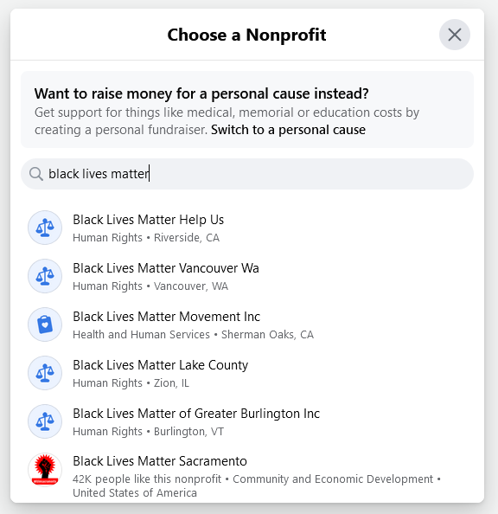](https://user-images.githubusercontent.com/6005325/121228479-a913ab00-c841-11eb-9cd5-0c1587002c2d.png)

Black Lives Matter, hereby referred to as BLM, started out as a good idea based on bad data. The BLM narrative is that white supremacist cops are gunning down unarmed black men, and this has caused black people to be murdered at double the rate of white people. This is a false narrative. Black Americans make up about 1/6 the US population but they account for over half of all murders committed, which is almost 20,000 per year. The number of people killed by far-right extremists in the US since the start of the KKK is only about 3,000 Black Americans murdered. For each unarmed black man killed by police there are over 1000 black men killed by black men. It's the elephant in the room. BIG TECH has been unlawfully censoring Americans independent news and political commentary, but they never stop the disinformation that is causing the riots. Facebook even directly profits by taking a small percent of the donations to BLM fundraisers.

The money raised on BLM fundraisers more often than not doesn't go to where the fund raisers claim it will but instead is absorbed into administrative costs. The money BIG TECH has raised in BLM fundraisers has been used to fund riots, while BIG TECH censors all opposition to riots such as Right-wing militias from being able to use their Second Amendment Rights to serve America as a well-regulated militia. A well-regulated militia is akin to a police force during emergencies.

### N. BIG TECH profits from and props up Big Media who gas light with false claims that prevents citizens from getting fair trials.

One of the most successful methods that journalist use get clicks is to gas light people. What this means is that you make them mad. RSS Commentary, one of the Plaintiffs, studied RSS feeds, RSS is a file format that most major news outlets use to publish their news digitally, and found an exceedingly high percent of the articles contained things that a politician said or did that make people angry. In the Trump Presidency there was a pervasive problem of journalist’s piggy backing Trump's fame by publishing false claims about what Trump said and did to gaslight the crowd, which amped up the race riots of 2020.

In the Kenosha riots of 2020 Right-wing militia member Kyle Rittenhouse, who was a member of a well-trained militia, shot and killed two rioters and blow the arm off another. Rittenhouse was then politically prosecuted was forced to serve jail time for self-defense. Twitter banned RSS Commentary for supporting Kyle Rittenhouse. RSS Commentary appealed the suspension, but the appeal was taking weeks, so eventually RSS Commentary gave up and canceled the appeal and deleted the tweet. BIG TECH censorship like this resulted in Kyle Rittenhouse having a less fair trial due to manipulated public perception of support for Kyle Rittenhouse and his use of the Second Amendment.

[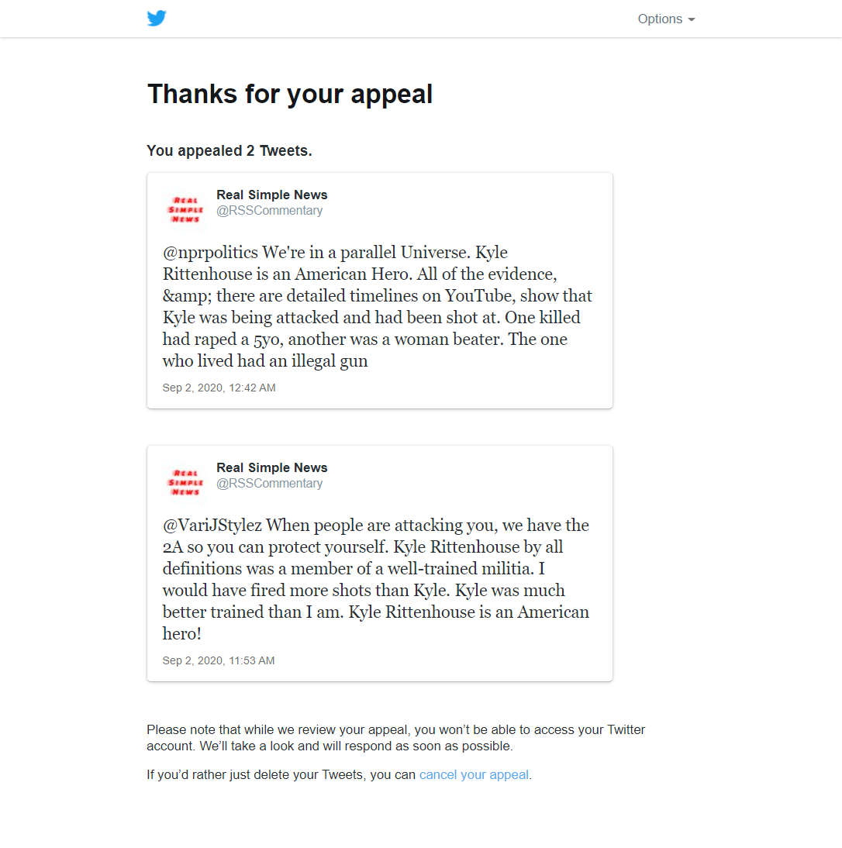](https://user-images.githubusercontent.com/6005325/121395998-cb6ffc00-c907-11eb-8124-36885ea636cf.png)

Officer Derek Chauvin, the one who restrained George Floyd leading to a heart attack, was also not able to receive a fair trial due to Big Media profiting on pushing a false narrative that cops are trying to kill unarmed black men.

### O. BIG TECH fortified Biden and suppressed Trump in the 2020 Election in a 'shadow campaign' of election engineering.

In the Times Magazine article The Secret History of the Shadow Campaign That Saved the 2020 Election, published February 4, 2022 5:40 AM EST the authors allege that there was a 'Shadow Campaign' that operated without the General public knowledge using corporate resources that constitute illegal campaign contributions to engineer the 2020 US President election, and covering up of ballot harvesting dumps that caused statistical anomalies that triggered rampant conspiracy theories around Dominion Systems voting machines. In this article the group of people who engaged in election engineering admitted their crimes to the Times Magazine reporter Molly Ball in order to get ahead of the story and control the narrative. “It was all very, very strange,” Trump said on Dec. 2. “Within days after the election, we witnessed an orchestrated effort to anoint the winner, even while many key states were still being counted.” This article was published two days before the January 6 US Capitol Siege Democrats are labeling as an 'insurrection'. This article did contribute to the riot on January 6.

In the Times Article it reads, with they meaning the Shadow Campaign:

Their work touched every aspect of the election. They got states to change voting systems and laws and helped secure hundreds of millions in public and private funding. They fended off voter-suppression lawsuits, recruited armies of poll workers and got millions of people to vote by mail for the first time. They successfully pressured social media companies to take a harder line against disinformation and used data-driven strategies to fight viral smears. They executed national public-awareness campaigns that helped Americans understand how the vote count would unfold over days or weeks, preventing Trump’s conspiracy theories and false claims of victory from getting more traction. After Election Day, they monitored every pressure point to ensure that Trump could not overturn the result. “The untold story of the election is the thousands of people of both parties who accomplished the triumph of American democracy at its very foundation,” says Norm Eisen, a prominent lawyer and former Obama Administration official who recruited Republicans and Democrats to the board of the Voter Protection Program.

That’s why the participants want the secret history of the 2020 election told, even though it sounds like a paranoid fever dream–a well-funded cabal of powerful people, ranging across industries and ideologies, working together behind the scenes to influence perceptions, change rules and laws, steer media coverage and control the flow of information. They were not rigging the election; they were fortifying it. And they believe the public needs to understand the system’s fragility in order to ensure that democracy in America endures.

The "Architect" of this plan was a gentleman named Mike Podhorzer, the senior advisor to the President of the AFL-CIO, which is extremely influential in the Democrat party. Among Democratic insiders, he’s known as the wizard behind some of the biggest advances in political technology in recent decades. Mike Podhorzer is also a supporter of Biden's open-boarder and Sanctuary nation policies that are flooding large cities with illegal immigrants to boost the population of the big democrat-run cities in order to control US Federal elections by diluting the votes of the rural Red States. Mike Podhorzer and the Democrats don't care Open-board and Sanctuary Nation policies are illegal and cause the legal immigrants in the big cities and minorities and low-income people to go homeless, they just access to the illegal immigrants’ kids to "Vote blue no matter who", which means always vote for Democrats because Republicans want to deport their parents, creating an us versus them conflict that breeds racial resentment and hatred. Podhorzers said “We desperately need to systematically ‘red-team’ this election so that we can anticipate and plan for the worst we know will be coming our way.”

On March 3, Podhorzer drafted a three-page confidential memo titled “Threats to the 2020 Election.” “Trump has made it clear that this will not be a fair election, and that he will reject anything but his own re-election as ‘fake’ and rigged,” he wrote. “On Nov. 3, should the media report otherwise, he will use the right-wing information system to establish his narrative and incite his supporters to protest.” The memo laid out four categories of challenges: attacks on voters, attacks on election administration, attacks on Trump’s political opponents and “efforts to reverse the results of the election.”

Protecting the election would require an effort of unprecedented scale. As 2020 progressed, it stretched to Congress, Silicon Valley and the nation’s statehouses. It drew energy from the summer’s racial-justice protests, many of whose leaders were a key part of the liberal alliance. And eventually it reached across the aisle, into the world of Trump-skeptical Republicans appalled by his attacks on democracy.

In March, activists appealed to Congress to steer COVID relief money to election administration. Led by the Leadership Conference on Civil and Human Rights, more than 150 organizations signed a letter to every member of Congress seeking $2 billion in election funding. It was somewhat successful: the CARES Act, passed later that month, contained $400 million in grants to state election administrators. But the next tranche of relief funding didn’t add to that number. It wasn’t going to be enough.

Private philanthropy stepped into the breach. An assortment of foundations contributed tens of millions in election-administration funding. The Chan Zuckerberg Initiative chipped in $300 million. “It was a failure at the federal level that 2,500 local election officials were forced to apply for philanthropic grants to fill their needs,” says Amber McReynolds, a former Denver election official who heads the nonpartisan National Vote at Home Institute.

In Philadelphia, for example, advocates distributed “voting safety kits” containing masks, hand sanitizer and informational brochures. “We had to get the message out that this is safe, reliable, and you can trust it,” says Hannah Fried of All Voting Is Local.

In the end, nearly half the electorate cast ballots by mail in 2020, practically a revolution in how people vote. About a quarter voted early in person. Only a quarter of voters cast their ballots the traditional way: in person on Election Day.

Laura Quinn, a veteran progressive operative who co-founded Catalist did research that showed that engaging with toxic content only made it worse. “When you get attacked, the instinct is to push back, call it out, say, ‘This isn’t true,'” Quinn says. “But the more engagement something gets, the more the platforms boost it. The algorithm reads that as, ‘Oh, this is popular; people want more of it.'”

The solution, she concluded, was to pressure platforms to enforce their rules, both by removing content or accounts that spread disinformation and by more aggressively policing it in the first place. “The platforms have policies against certain types of malign behavior, but they haven’t been enforcing them,” she says.

Quinn’s research gave ammunition to advocates pushing social media platforms to take a harder line. In November 2019, Mark Zuckerberg invited nine civil rights leaders to dinner at his home, where they warned him about the danger of the election-related falsehoods that were already spreading unchecked. “It took pushing, urging, conversations, brainstorming, all of that to get to a place where we ended up with more rigorous rules and enforcement,” says Vanita Gupta, president and CEO of the Leadership Conference on Civil and Human Rights, who attended the dinner and also met with Twitter CEO Jack Dorsey and others. (Gupta has been nominated for Associate Attorney General by President Biden.) “It was a struggle, but we got to the point where they understood the problem. Was it enough? Probably not. Was it later than we wanted? Yes. But it was really important, given the level of official disinformation, that they had those rules in place and were tagging things and taking them down.”

After election day, the Shadow Campaign set into action to uphold the results of the 2020 election, with AFL-CIO working with U.S. Chambers of commerce, organized by Neil Bradley, two organizations that have historically been at odds due to AFL-CIO backing Democrats and U.S. Chamber of Commerce backing Republicans. Black Lives Matter rioters were threatening to burn the Country down if Trump was reelected and they were determined to use all means necessary to achieve the election outcome they wanted and had invested so much time and money into. The Shadow Campaign then used BIG TECH platforms to control all the choke points of information to control the national dialog over alleged voter fraud. The Shadow Campaign used ballot harvesting and covered up evidence of their use of ballot harvesting, which may violate Federal election laws against destruction of election related materials.

### P. BIG TECH biases search results in favor of Big Media and does not classify Plaintiffs as real news.

BIG TECH is a monopoly that has their own news product. BIG TECH is the arbiter of truth that classifies your news as either the real news, or the fake news. Forbes is a former American news outlet that was sold to Integrated Whale Media Investments in 2014 and now operates out of Hong Kong. As you can see in this screen capture of YouTube's news product, that Forbes Breaking News is featured in the news section, but the Epoch Times news program Facts Matter with Roman Balmakov, which is a company was founded in 2000 by John Tang and a group of Chinese-American Falun Gong practitioners. Falun Gong is an ethnic minority that was targeted for genocide by Cultural Marxism in China. YouTube props up the enemy of Falun Gong while suppressing legitimate news from Falun Gong. Most major news outlets such as NBC, ABC, Bloomberg, CNN, hereby referred to as Big Media, are all deeply infested in 'communist' China. The quotes around communist are there because there is no private property or capitalism allowed in communist countries, only in fascist countries. Most of the news outlets promoted by BIG TECH as legitimate news are in fact censored just enough to not interfere with the respective Big Media outlet's parent company's Chinese business connection. This presents a national security concern.

[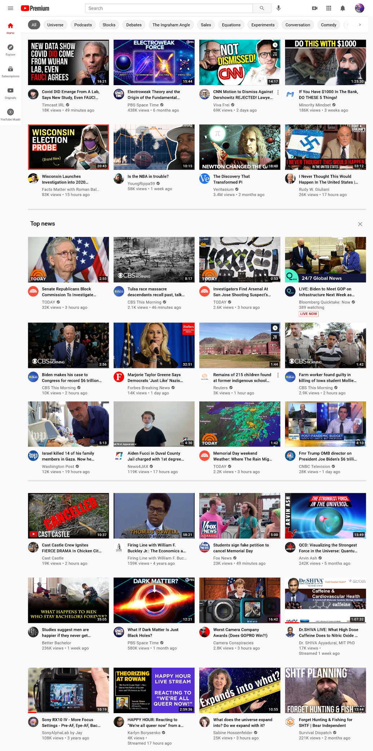](https://user-images.githubusercontent.com/6005325/121411667-bcde1080-c918-11eb-909d-931c05cbf0d5.png)

### Q. Wikipedia has defamed Plaintiffs by publishing false and defamatory statements and edit blocking the QAnon, Great Replacement, and other articles that contain false facts defaming Plaintiffs as far-right, Wikipedia has banned anyone who attempts to correct the false facts claiming they are Nazis under the Wikipedia No-Nazi policy, and the Wikipedia has engaged in an election engineering cover-up.

Wikipedia has been one of the primary sources of false defamatory statements that Plaintiffs is far-right dangerous content. When information content providers, hereby referred to as ICP, as defined under Section 230, that user is the speaker and publisher of that information. Plaintiffs has attempted to correct the false and defamatory statements both in the Wikipedia articles and in the Wikipedia Talk section, and Wikipedia has reverted the changes back and banned members of Plaintiffs, telling us that we’re Nazis and we violated the Wikipedia No-Nazi policy. Nazis are a hate group that has engaged in mass murder and genocide and Nazis are shunned and socially excluded. When Wikipedia reverts changes back to the claims made from the original ICP, Wikipedia owns the copyright to that speech and Wikipedia is thus the speaker and publisher of that speech.

Democrats are using Replacement Migration to augment the birthrate of their voter base to engineer Federal election outcomes. Replacement Migration is the officially recommended policy of the United Nations and when the migrants population grows larger than the native population, it is functionally identical to the Great Replacement. Wikipedia has covered u the Great Replacement is not happening, and it’s because the Wikipedia amin are openly Black Lives Matter and Antifa supporters. Wikipedia is in Silicon Valley where almost everyone votes for Democrats. The Democrat party and Democrats in Congress has been engaging in the Great Replacement coverup with Wikipedia by publicly denying it is happening. The Democrats in Congress know very well that the native-born US population is rapidly disappearing because it’s been brought up many times in meetings about the US Census and because the Democrats remaining in power depends on replacing their aging voters.

The following graph is from the US Census Bureau from a document entitled “A Changing Nation: Population Projections”. Plaintiffs attempted to add this to the Wikipedia Great Replacement article and was banned, and Wikipedia made a statement of fact that Plaintiffs had violated the No-Nazi Policy. The graph shows that if the US cut off immigration, the US population would go down to 319.7 million by 2060. This is because native-born American’s birthrate is about 1.64 births per woman post-COVID, and the replacement rate is 2.1 births per woman. Under a low immigration scenario, the US population would be 376.2 million, medium immigration it would be 404.5 million, and at high immigration levels it would be 446.9 million.

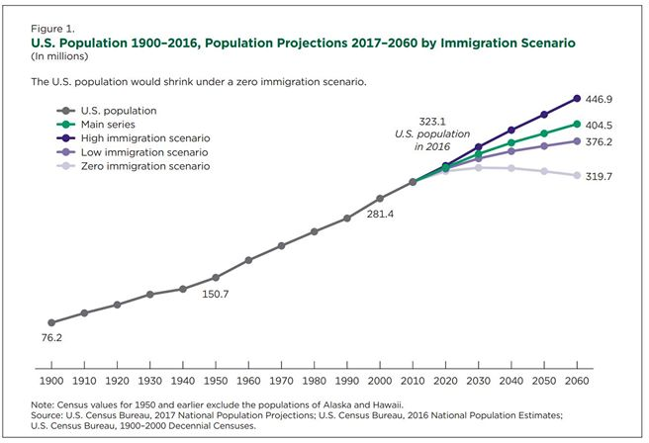

The Democrats want the high immigration scenario because about 2/3 of Latinos vote for Democrats because Democrats give people SNAP and welfare, mostly first-generation Latinos. The Republicans want the low immigration scenario to preserve our culture, traditions, and way of life as well as preserving our majority status so that we can self-govern. Democrats are defaming Republicans as far-right white nationalist for opposing open borders, and Wikipedia has become a propaganda outlet for Democrats. A large percent of both Democrats and Republicans want the no immigration scenario, it’s not just the far-right that wants an immigration freeze. The Democrats are the ones who are responsible for the policies that are causing low birthrate, which is liberalism and feminism. The corporations are convincing women to give up having kids until their 30s so they can be ‘equal’, equal meaning men are treated like women and women are treated like men. When women do that their birthrate tanks and they have on average one child. The conservative population’s birthrate is over the replacement rate and is growing. Democrats can’t admit to the US public that everything Democrats have been pushing is a colossal failure that is causing native-born Americans to disappear. At the current rate of migration, which people will become a minority in the US by 2060 at the latest. Democrats know this is happening, but they need to keep it secret because no culture This means that it’s a required for Democrats to have the high immigration scenario to maintain their grip on power over the US Congress. After Joe Biden was elected president, he immediately opened the US southern border and caused a flood of millions of mass migrants to illegally immigrate to the US. The Congress has been abridging free speech on Wikipedia for the purpose of engineering election outcomes via packing the electorate using open borders.

The open borders have caused cartel human smuggling networks to take over the Southern border. The cartels have been smuggling in enough fentanyl each month to kill everyone in the US. The cartels are getting the precursor chemicals from China, and the Chinese Communist Party has been sanctioning this to use the drugs as chemical weapons against the US. The cartels are using children to distract Customs and Border Patrol agents while the cartels smuggle in humans and drugs. Many of the children who make it through undetected are sold into sex trafficking. For this reason, the Democrats are controlled by a pedophile sex trafficking network because the Democrats.

Democrats support abortion. Abortion is a Satanic Ritual according to the Church of Satan. Democrats support abortion because Democrats used to force sterilize people when they had control over the US Congress for over a century until 1995-6 when Republicans took control, then 9-11 happened after the Democrats lost control of the White House. Democrats used to be the racial superiority party and they force sterilized poor and dumb people, and non-whites. Democrats endorse abortion because they claim it discriminates against low-income women, and that’s because they were trying to sterilize them because they thought they were genetically inferior. Many Conservatives considers abortion to be Satanic, and they believe Democrats are demonic Satan worshipers.

In 2003 the billionaire pedophile sex trafficker Jerry Epstein was convicted of Soliciting prostitution from a minor in Florida. In 2022 his accomplish Ghislaine Maxwell was convicted of sex trafficking minors for Epstein. Below is a picture of Bill Clinton getting a back massage from one of Epstein’s alleged sex trafficking victims and Mr Epstein.

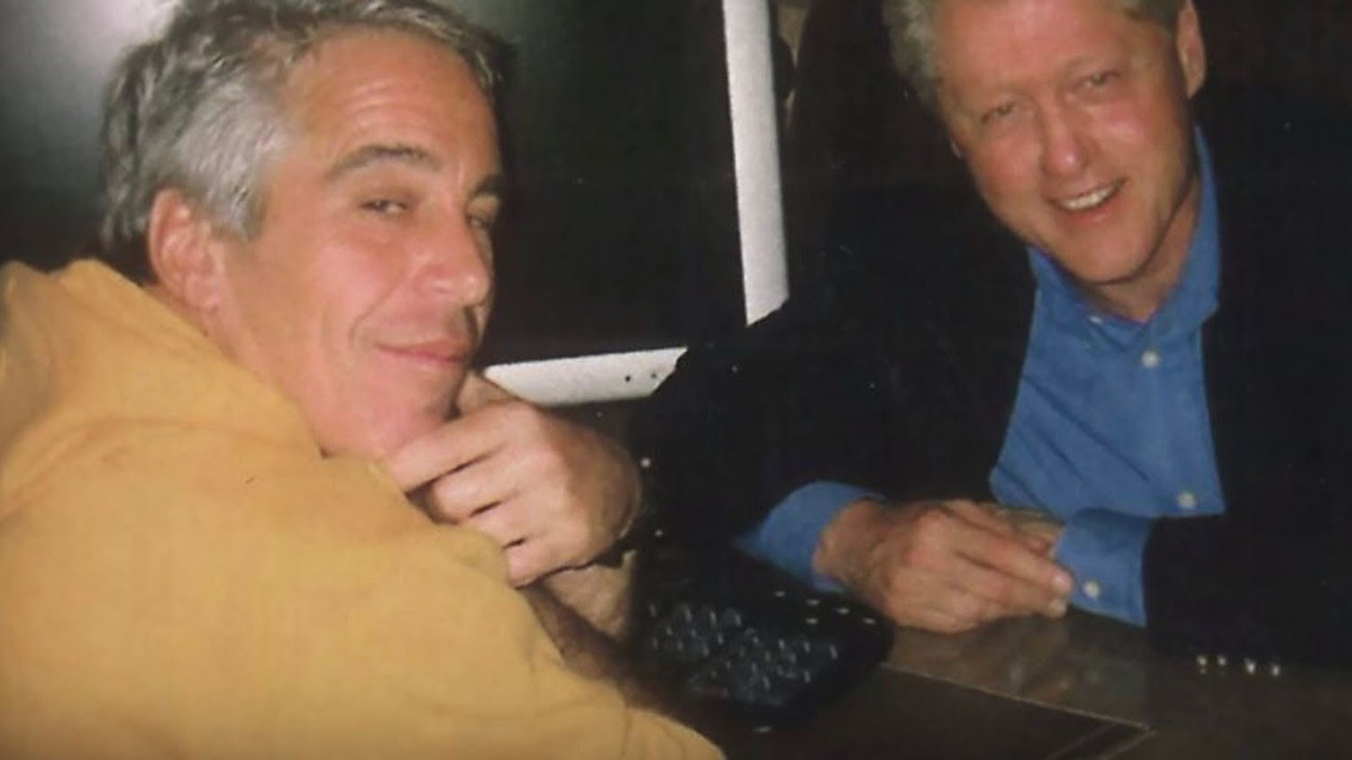

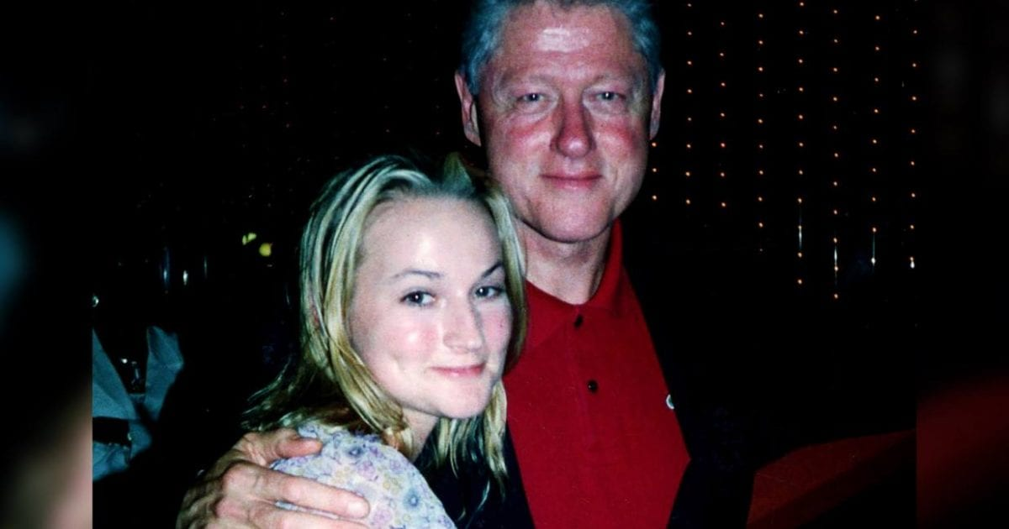

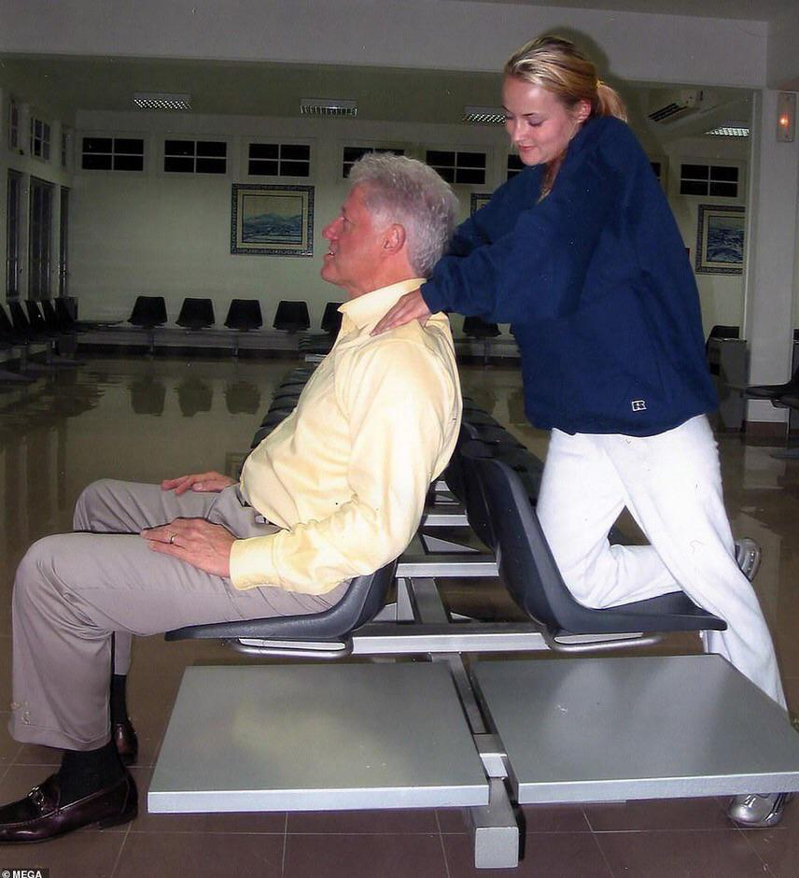

Given the Democrats turning a blind eye to the child sex trafficking network and the relationship with Epstein and the Clintons, it’s fair to say that the Democrats are controlled by a Pedophile sex trafficking network, and given the Steele Dossier Russiagate hoax Democrats used to engineer the 2020 election outcome, it’s 100% factual and correct to say that Democrats have engaged in a Deep State conspiracy against President Trump.

Wikipedia defamed Plaintiffs by publishing false and defamatory claims about QAnon and Great Replacement for the purpose of painting Trump supporters as far-right conspiracy theory extremist akin to Nazis who committed genocide who are to be shunned, hated, canceled, and ostracized for the specific purpose of discrediting the facts to deceive the American public.

### R. BIG TECH has defamed and caused psychological and emotional injuries to Plaintiff’s members as described in each member's "Declaration in Support of Petition".

Each member of the class of people Plaintiffs has a different list of psychological and emotional injuries unique to their personal business and public relationship with BIG TECH. Each member of the class Plaintiffs shall submit a document with this case file with a title that begins with "Declaration in Support of Petition", and this Declaration shall include a description of the injuries.

### S. BIG TECH caused $1.6 billion in tort-actionable damages to Plaintiffs.

BIG TECH has an unlawful monopoly that control the speech of a large percent of the US and the world. BIG TECH has unlawfully abused 47 US Code § 230 to unlawfully censor Republicans on the behalf of Democrat lawmakers related to Kamala Harris that was intended to fortify the election for Biden to suppress Trump on the false pretense that Russian disinformation was enough of a threat to the election to justify using a 'Shadow campaign' to stifle Plaintiffs to prevent our products from being commercially viable in order to prop up media outlets with deep ties in fascist China. BIG TECH's actions are a violation of the Sherman anti-trust act. BIG TECH's censorship of Plaintiffs was intended to censor US Citizens independent news and political commentary in the future that has not occurred yet.

### T. This Court has jurisdiction over these questions of law at hand and this is the most suitable Court to hear these questions of Federal Law.

## CAUSES OF ACTION

FIRST CAUSE OF ACTION:

LIBEL

SECOND CAUSE OF ACTION:

FALSE LIGHT INVASION OF PRIVACY

THIRD CAUSE OF ACTION:

INTENTIONAL INFLICTION OF EMOTIONAL DISTRESS

FOURTH CAUSE OF ACTION:

NEGLIGENT INFLICTION OF EMOTIONAL DISTRESS

FIFTH CAUSE OF ACTION:

COMMON-LAW MISAPPROPRIATION OF

MR. OBEIDALLAH’S NAME AND LIKENESS

SIXTH CAUSE OF ACTION:

CIVIL CONSPIRACY

### Jury Trial

Plaintiff demands a jury trial. The Questions of law that we are respectfully requesting the Court to decree an answer to answer are:

1. Has BIG TECH unlawfully defamed Plaintiffs?
2. Does BIG TECH have a monopoly over information service providers of election related information distribution?
3. Is BIG TECH a corporate town?
4. Is BIG TECH's use of sophisticated AI algorithms to modify the public's behavior through psychological manipulation an illegal campaign contribution to the Democrats?
5. Is BIG TECH's use of sophisticated AI algorithms to modify the public's behavior through psychological manipulation protected under 47 US Code § 230?
6. Has BIG TECH unlawfully censored Plaintiffs using 47 US Code § 230 on behalf of Democrats?
7. Has BIG TECH engaged in a cover-up of Great Replacement and QAnon in order engineer election outcomes to ensure Democrats control Congress and the White House?
8. Is BIG TECH liable for damages to Plaintiffs?

**THEREFORE,** Plaintiff Dean Obeidallah respectfully requests that the Court

grant the following relief:

a. Compensatory damages, including economic and non-economic damages;

b. General damages;

c. Special damages;

d. Punitive damages, including attorneys’ fees and costs;

e. Nominal damages;

f. Attorneys’ fees, costs, and disbursements, to the extent permitted by law;

g. Such other and further relief as the Court deems just.

I declare (or certify, verify, or state) under penalty of perjury that the foregoing is true and correct and that this Petition was placed in the _____________________________________ on ____________, 2022.

Respectfully submitted __________________________, 2022.

The class of people Plaintiffs:

x___________________________________________  
Petitioner RSS Commentary  
Date: __________________________, 2022

x___________________________________________  
Petitioner _______________________________  
Date: _____________________________, 2022

x___________________________________________  
Petitioner _______________________________  
Date: _____________________________, 2022

x___________________________________________  
Petitioner _______________________________  
Date: _____________________________, 2022

x___________________________________________  
Petitioner _______________________________  
Date: _____________________________, 2022

x___________________________________________  
Petitioner _______________________________  
Date: _____________________________, 2022

x___________________________________________  
Petitioner _______________________________  
Date: _____________________________, 2022

x___________________________________________  
Petitioner _______________________________  
Date: _____________________________, 2022

x___________________________________________  
Petitioner _______________________________  
Date: _____________________________, 2022

x___________________________________________  
Petitioner _______________________________  
Date: _____________________________, 2022

x___________________________________________  
Petitioner _______________________________  
Date: _____________________________, 2022

x___________________________________________  
Petitioner _______________________________  
Date: _____________________________, 2022

x___________________________________________  
Petitioner _______________________________  
Date: _____________________________, 2022

x___________________________________________  
Petitioner _______________________________  
Date: _____________________________, 2022

## Appendix

**1.** Email from California Secretary of State Xavier Becerra to Mark Zuckerberg, Jack Dorsey, and Susan Wojcicki.

<https://oag.ca.gov/sites/default/files/Election%20Interference%20Letter_10-19-2020.pdf>

**2** Email from Mark Zuckerberg to Dr Anthony Fauci's Email from FOIA request.

[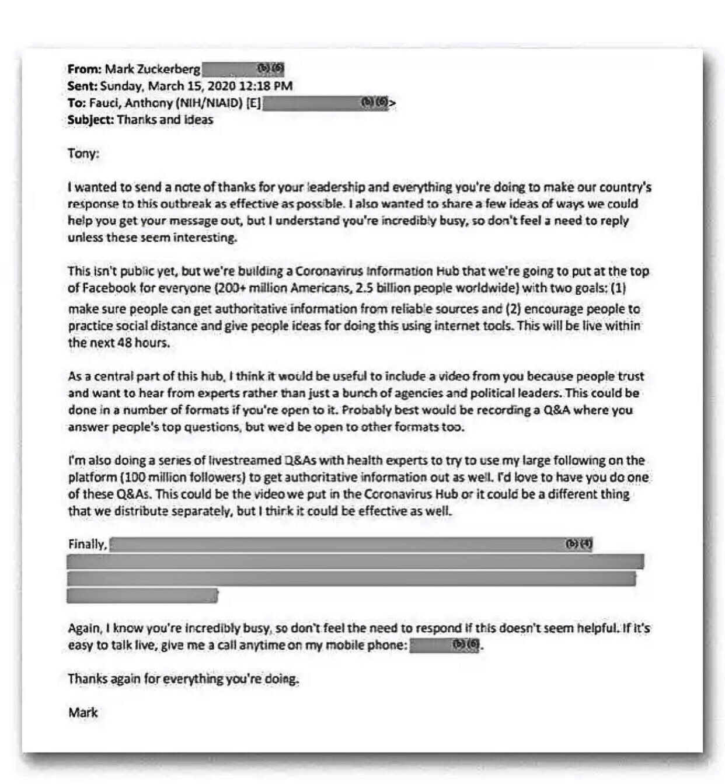](https://user-images.githubusercontent.com/6005325/121294414-35ee5100-c8a2-11eb-9842-469fd563c5e4.png)

**3** Dr Anthony Fauci email response to Mark Zuckerberg.

[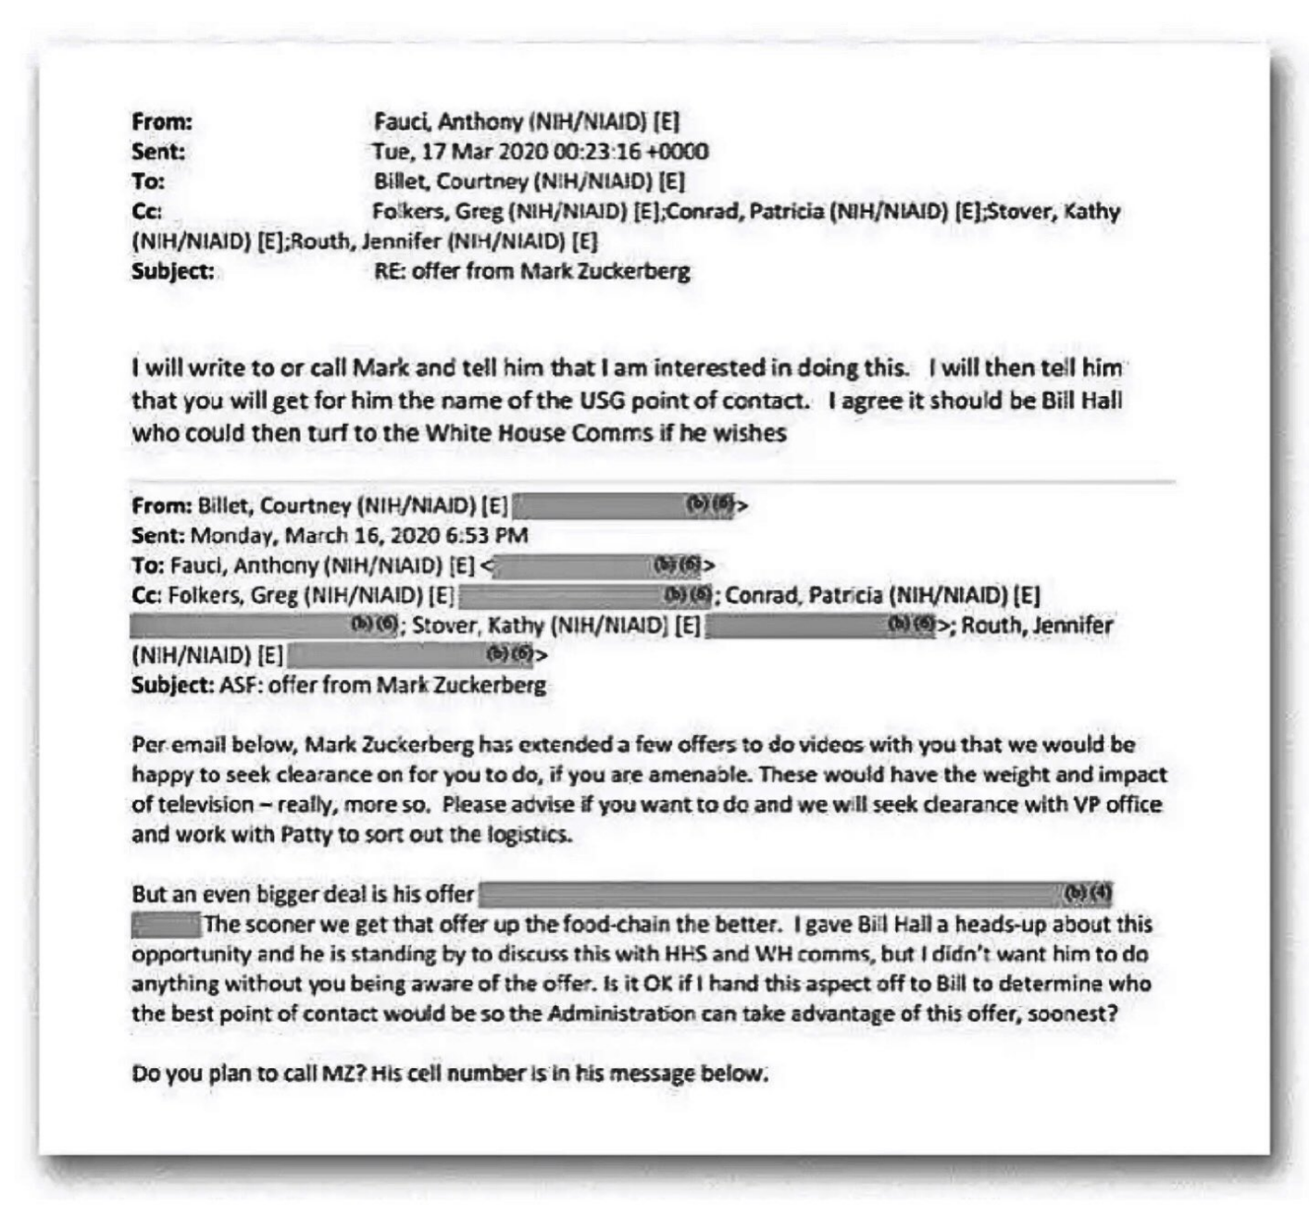](https://user-images.githubusercontent.com/6005325/121294575-7a79ec80-c8a2-11eb-9e41-71a56b71aeff.png)

**4** Exhaustive list of Cale McCollough's Facebook censorship.

[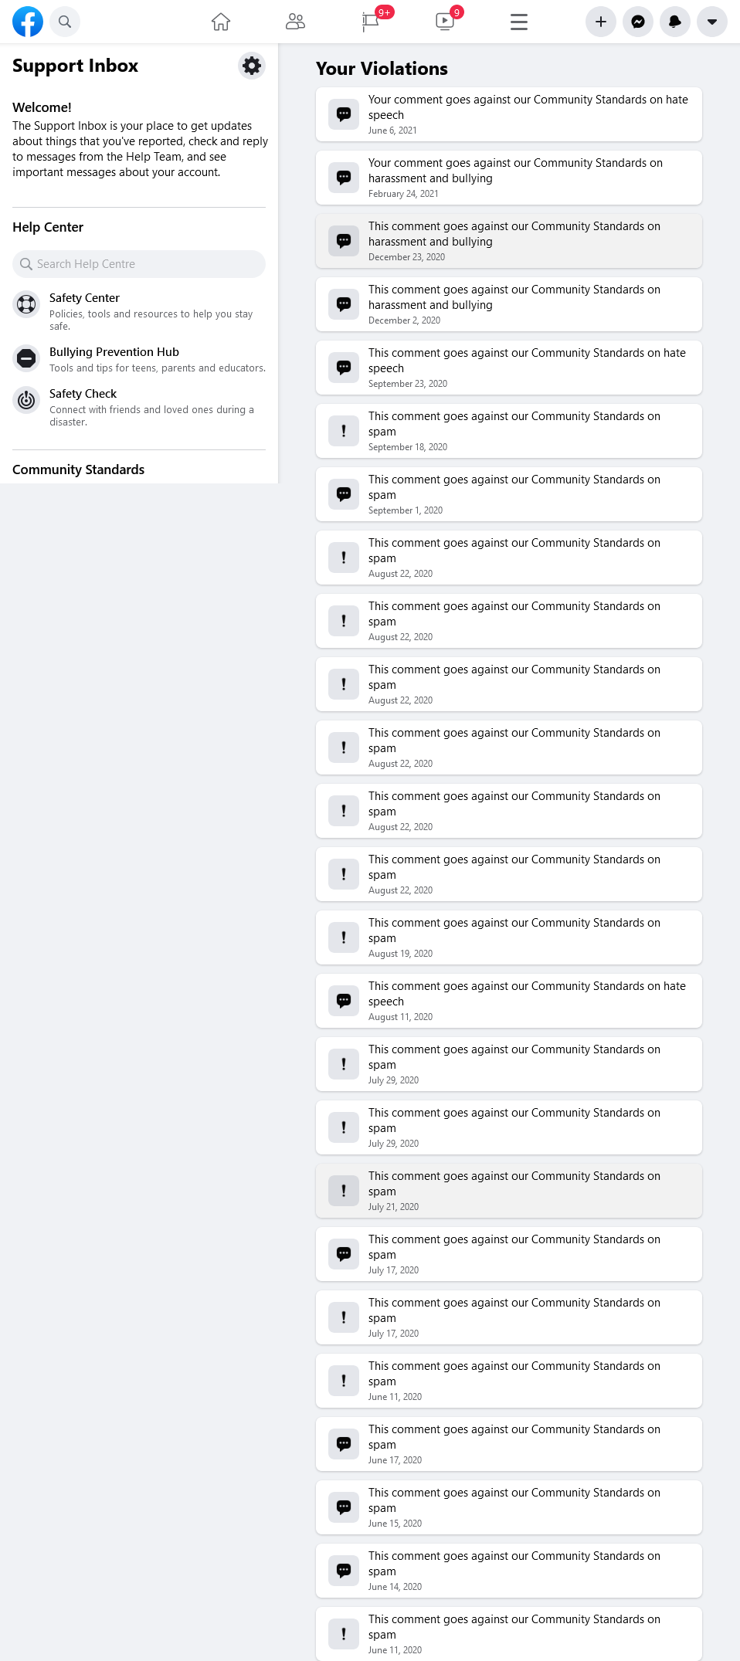](https://user-images.githubusercontent.com/6005325/121579722-cfbc1800-c9e0-11eb-8c78-bebf2404451e.png)